**Computer Organization and Assembly Language**

|  |  |
| --- | --- |
| **Lab 09** | |
| **Topic** | 1. MUL, IMUL, DIV and IDIV instructions |

**PART 2**

**Problem #3**

**Write an assembly language program to convert the temperature units.**

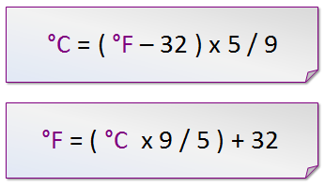

**a)**

**b)**

*For example:* 35℃⬄95℉

**Note: ignore decimal results.**

**Problem # 5**

**Write an assembly language program to find the prime numbers in an array.**

**If a number is prime replace it with 1 else if it is not replace with 0.**

Let values are (byte size)

|  |  |  |  |  |  |  |  |  |
| --- | --- | --- | --- | --- | --- | --- | --- | --- |
| Index | 0 | 1 | 2 | 3 | 4 | 5 | 6 | 7 |
| Value | 0x05 | 0xEF | 0xDE | 0x64 | 0x38 | 0x0D | 0x84 | 0x15 |

|  |  |  |  |  |  |  |  |  |
| --- | --- | --- | --- | --- | --- | --- | --- | --- |
| Index | 0 | 1 | 2 | 3 | 4 | 5 | 6 | 7 |
| Value | 1 | ? | ? | ? | ? | ? | ? | 0 |